Lunch and Learn
Power Point 2007 Projects
1/6/10
Noon to 1 PM
Leecy Wise
GOAL: To practice skills to immerse students in creating their own Power Point projects to learn content along with the technology required.

Objective 1 | Create flash cards for GED/ABE/ESL and Foreign Language students.
Examples of Flash Card Uses | Match pictures with vocabulary – from basic to technical or professional vocabulary  Conjugate verbs  Match words with definitions  Match art with artists  Match dates with events  Conjugate verbs  Solve math problems  NOTE: In this session, we will practice printing cards that students can cut and carry with them. However, many instructors simply have students use the flashcards in PP. There are many individual and collaborative variations. Have students use those they prefer as a learning tool.  Instructions are included in the last two slides of the attached Power Point Show.
Instructions for Creating Flash Cards (Instructions are also included in the last two slides of the attached sample Power Point Show.) | Create Content  - Develop the list of items for the faces of each card in the deck.  - Apply your desired slide theme.  - Enter the first item for the first face of a card on your first slide.  - Copy and paste that slide as many times as you wish to match the number or items on your list.  - Substitute the name of the item in each slide copied.  - Go to your first slide and enter a new slide to follow it with the information you want on the flip side of that card.  - Copy and paste that slide after each of the face items you entered before, and substitute the information you want for the flip side of each item  Print Content  - Click on PRINT from the Windows menu, and select the Handouts option. That’s where you will see the layout of your flash cards on the page. Select six slides per page and print.  - I laminate the whole page, cut out the cards with a paper cutter, and staple the two sides from there. Of course, you may choose not to laminate and glue the two sides together for cards.  - If you want the cards printed front and back, simply change the arrangement of the cards in the slide sort view so that you print on both sides. This will teach your students great spatial-perception skills! In that case, you will create the first six face cards (1,2,3,4,5,6) followed by the six definitions going in the opposite sequence: 7-2, 8-1, 9-4, 10-3,11-6, and 12-5). Then start the next sequence. You may have to print a couple of pages to make sense of the process.  - Print both sides. Place them together. Laminate the pages and cut. Bingo! (In fact, you might take a look at the instructions for creating Bingo cards from an earlier LL.)  Printing a PDF: http://presentationsoft.about.com/od/powerpoint2007tips/ss/07saveasPDF_3.htm
Objective 2 | Create a photo album for GED/ABE/ESL and Foreign Language students.
Objective 2  Examples of Photo Album Uses. | Illustrate researched items: plants, foods, anatomy, observations, geography, maps.  Record a trip.  Share family photos.  Create a picture dictionary.  Illustrate geometry concepts.
Objective 2  Examples of Photo Album Uses. | Create a photo album from saved images.  Create a folder on the desktop called Photo Album.  Populate with images and rename images.  Open PP.  Insert -> Photo Album  Insert Picture From: File/Disk  Select the folders with your pictures.  Select all of the pictures (Control + A)  Insert -> Create  Give it a design. (Design Tab)  Add labels with text boxes or Word Art
Saving Options  (Remember the copyright issue if you share online. You need permission to use images.) | For sharing  For teaching  For group editing and projects  http://presentationsoft.about.com/od/powerpoint101/ig/PowerPoint-2007-Ribbon/save-as.htm  Saving: You should save your presentation as soon as you open it and all through the process of creating the project.  To save your project, click on Save (Control + S) from the Windows menu. Select the location for saving your file. Name your file and save.  Later, to save in different formats, click on Save As. When the window opens, go to the Save As Type box and select the options you want.  - .pptx – Saves in new XML-based default file format used by PowerPoint 2007 for presentations, which uses compression technology to make file sizes smaller, structures files modularly so different components are kept separate for better recovery, and integrates easily with other programs that support XML standards.  - .ppt – Saves as a presentation compatible with 97-2003.  - ,pdf – Saves as a PDF file.  - .ppsx – Saves as a 2007 PP show, which opens in full screen, regardless of whether the viewer has PP on the machine.  - .pps - Saves as a 97 -2003 show, which opens in full screen, regardless of whether the viewer has PP on the machine.  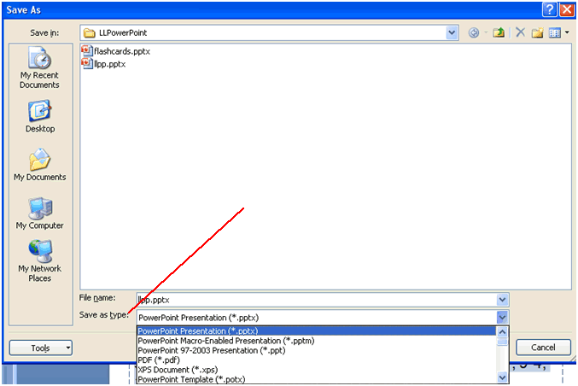
Flashcards: http://www.edzone.net/~mwestern/tutorials/pptflashcards.pdf

Albums
- http://www.smallbusinesscomputing.com/biztools/article.php/3808241
- http://www.ducttapemarketing.com/article/articles/1362/1/Share-Thanksgiving-PowerPoint-Photo-Albums-to-Gain-More-Happiness/Page1.html - with sharing ideas
- http://presentationsoft.about.com/od/powerpoint2007/ss/080426photoalb.htm - How to with other links
Games
- http://jc-schools.net/tutorials/Ppt-games/
- http://people.uncw.edu/ertzbergerj/ppt_games.html
A Few Sharing Tools (There are many!)
- http://www.slideshare.net/ - Upload projects here. See an example on the following link:
- http://www.slideshare.net/Leecy/engaging-students-1604403
- http://www.slideshare.net/ -
- http://www.myplick.com/

Power Point Tutorials
Check out links in previous Power Point Lunch and Learn sessions for dozens of powerful links to teach with Power Point.

